AMMAN ARAB UNIVERSITY
جامعة عمان العربـيــــــة
College of Information Technology


كلية تكنولوجيا المعلومات

Online Art Gallery System

Students:
Maoua Abd Al-Wahab Wraikat | 202220753
Name of Student 2 | 22222222
Name of Student 3 | 3333333

Supervisor:
Dr. Ala Abu Thawabeh

Amman - Jordan
2025/2026

Table of Contents
1.1 Problem Statement and project Scope page 1
1.2 Project Plan and Schedule
2. System Analysis page 2
2.1 Functional Requirements
2.2 Use Case Diagram
3. System Design page 3
3.1 ER-Diagram (if a database will be used)
3.2 User Interface (prototype)

  - Problem Statement and project Scope

The system has been facing problems due to its paper-based appointment
system. With the increase in the number of patients visiting, it has
become diﬃcult to manage the appointment system manually. Recording
of appointments and creating registers by pen and paper has become a
The Online Art Gallery System is a web-based platform that allows
customers to browse, search, and purchase artworks online. The platform
provides detailed information about each artwork and ensures a smooth
and secure shopping experience.

To access the system, customers must register with an email and password.
Upon login, they can browse artworks by category, add items to their cart,
and complete purchases from the comfort of their home.

  - Project Plan and Schedule

Here is the Gantt Chart to schedule and manage the Online Art Gallery
project, and how tasks are distributed across this web project.

Figure 1: Gantt Chart of project

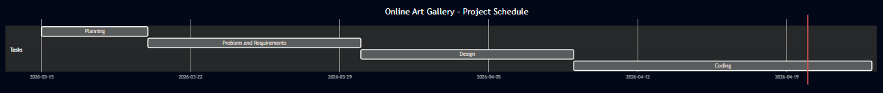

  - 2. System Analysis

2.1 Functional Requirements

1. User Authentication:
1.1. Allow users to create accounts and log in securely.
1.2. Provide options for password recovery and account management.

2. Artwork Catalog:
2.1. Display a well-organized catalog of artworks with images,
descriptions, and prices.
2.2. Implement search and filter options for easy navigation.

3. Shopping Cart:
3.1. Enable users to add artworks to their shopping cart.
3.2. Display the total cost including any applicable fees.
3.3. Allow users to edit the cart.

4. Responsive Design:
4.1. Ensure the website is mobile-friendly and works seamlessly
across various devices and screen sizes.
2.2 Use Case Diagram
The use case here is to show the interactions between the actors
(customer) and the actions (process).

Figure 2: Use Case diagram of system
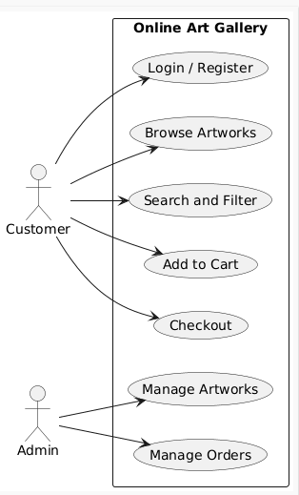

3. System Design

3.1 ER-Diagram

I used an ER diagram and tables in our project to store and manage data for the Online Art Gallery.

Figure 3: ER diagram of Appointment system
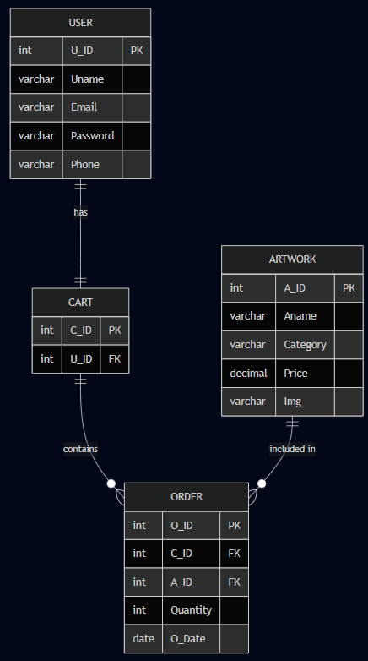

3.2 User Interface (prototype)

The following figures show the main pages of the Online Art Gallery system.

Figure 4: Main UI of Appointment system
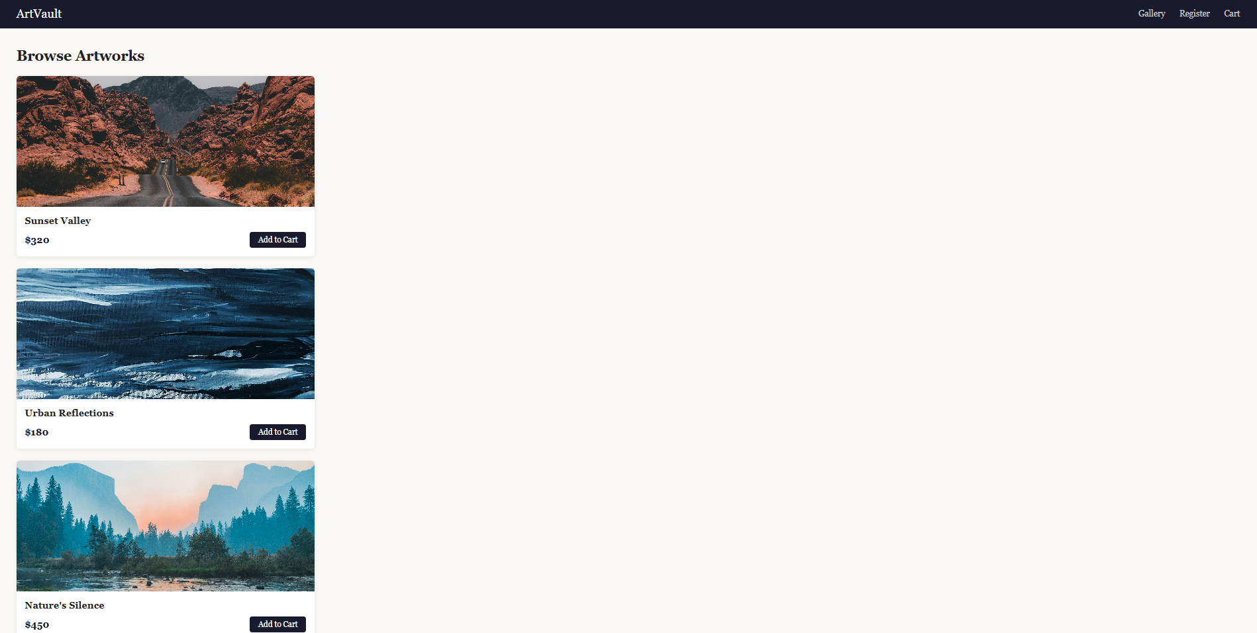

Figure 5: Show All UI of system

